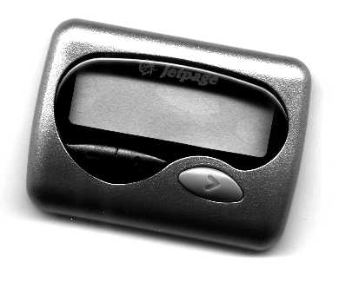
JP 420 (Bee)

PROGRAMMING INSTRUCTIONS

Button Function During Programming
( - ) Left Key: Used to confirm and complete each step of programming.
( ^ ) Middle Key: Used to change the value of flashing digit.
( > ) Right Key: Used to move the cursor from left to right.

Entering Programming Mode & Programming Procedure
Turn the pager off by pressing ( - ) and ( ^ ) simultaneously.
Once the pager is off, press ( ^ ) and ( > ) simultaneously until “PSW-0000” appears on the display. Use the keys described above to modify the password, then press ( - ) to go to the next screen. (Default password is 0909).

“SYMb- _U-][” should appear on the display after the above sequence is followed. Press ( ^ ) if necessary to set this screen to “SYMb- _U-][” for use in the United States. Press ( - ) to go to the next screen.

“Fr1- 2850000” should appear on the display. This screen will be used to set the frequency on future versions of this pager. Once programmed press ( - ) to go to the next screen. Certain Vhf/100Mhz frequencies (namely ones that are of 10Mhz and 20 Mhz channel spacing) will require a different number other than the frequency programmed into this part of the pager. To calculate the number you need to program multiply your frequency by 1.25. See example belowIf you have any question please contact your Jetpage distributor.

Example 152.480 x 1.25 = 190.6 157.74 x 1.25 = 197.175 152.24 x 1.25 = 190.3

“baud-2400” should appear on the display. Press ( ^ ) until the proper baud rate is displayed.
Press ( - ) to go to the next screen.

“Ad1- 1234567” should appear on the display. This is the current capcode. Use the keys described above to make changes to the capcode, then press ( - ) to go to the next screen.

“Ad2- dISAbLE” should appear on the display. You may press ( > ) to enter a secondary capcode or press ( - ) to go to the next screen. You can enter up to four different capcodes or keep pressing ( - ) to skip these settings.

“SurE ? nO” should appear on the display. You may press ( - ) to make changes to the programming or press ( ^ ) to change “nO” to “YES”.

Press ( - ) to complete the programming and to return to normal pager operation.

